

An Empirical Assessment of NYPD’s “Operation Impact”: A Targeted Zone Crime Reduction Strategy

Associate Professor Dennis C. Smith
Robert F. Wagner Graduate School of Public Service
New York University

Assistant Professor Robert Purtell
The Rockefeller College of Public Affairs & Policy
University at Albany
State University of New York

June 27, 2007

ACKNOWLEDGEMENTS

We wish to thank the Police Commissioner Raymond Kelly for inviting this evaluation, Deputy Commissioner Strategic Initiatives, Michael J. Farrell, for his assistance throughout this study, Deputy Chief John P. Gerrish and Inspector Michael Healey of the Office of Management Analysis and Planning for providing documents and helping us navigate the access and fieldwork part this study, and Assistant Commissioner Phillip McGuire of the Crime Analysis Unit for providing data and helping us understand it. We thank also precinct and borough commanders for taking their valuable time to explore with us their strategies in managing Impact Zones. We also are grateful to The University at Albany Associate Professor Gerald Marschke for his insightful advice on statistical methodology, and to our Research Assistant, NYU Wagner student, now graduate, Vaughn Crandall, for his help in the early stage of this study.

While the NYPD officials were responsive to multiple demands for data and on their time, they made no attempt to influence our conclusions.

We especially want to acknowledge and to thank the New York City Police Foundation for funding independent evaluations of NYPD programs and practices, including this one.

EXECUTIVE SUMMARY

About a decade ago one of the leading students of policing in America, David Bayley in a widely-praised book, Police for the Future, wrote “The Police do not prevent crime. This is one of the best kept secrets of modern life. Experts know it, the police know it, yet the police pretend that they are society’s best defense against crime.” In making this observation about the “myth” that police prevent crime Bayley was echoing the conclusion written more than two decades earlier of another distinguished expert, James Q. Wilson, who wrote in his pioneering empirical study of eight police departments, Varieties of Police Behavior, that the police administrator “is in the unhappy position of being responsible for an organization that lacks a proven technology for achieving its purpose”. Bayley was in the position to go further than Wilson and base his conclusion on research that “consistently failed to find any connection between the number of police officers and crime rates,” and studies of “primary strategies adopted by modern police” that found “little or no effect on crime”.

In the past decade and a half in the crime laboratory called New York City, these dire assessments of the plight of the police and by extension of the public have undergone a substantial revision. At the time Bayley published his commentary on the myth of police efficacy in preventing crime, New York City had used new police resources provided by Safe Streets, Safe City and a new police strategy called “community policing” to begin a reversal of an upward crime trend that had lasted more than a decade, and peaked in 1990 with more than 2,200 homicides. In 1993, a new anti-corruption system that would over time produce a two-thirds reduction in complaints of police corruption had been designed and implemented by then Police Commissioner Raymond Kelly, and in 1994 a new management system at the City, Borough, and Precinct level was being introduced that committed the police to fighting crime as the highest priority. Since then, crime has dramatically declined in every borough and every precinct in the City.
The remarkable achievement of crime reductions achieved from 1988 though 2001, led many to question whether it would be possible for a new administration to continue the relentless downward trend in crime.

The fear that crime had been brought down as much as was possible was not entirely unreasonable. Criminologists have long tracked the cyclical nature of crime patterns, and most people instinctively understand the economic concept of a “declining marginal return on investment,” the idea that “low hanging fruit” are found and harvested first, and that the challenges of production grow increasingly more difficult after that. For those who firmly believe, despite evidence, that the economy in New York rebounded after crime came down, that economic trends explain the crime rate, the economic downturn following the 911 attack further fueled pessimism about the prospects of continuing the successful fight against crime in New York.

Across the United States, the skepticism expressed in New York has been validated in cities large and small. After a decade long decline in crime in America’s big cities, recent national crime statistics show a disturbing upward turn. An October, 2006, Police Executive Research Forum report, “A Gathering Storm: Violent Crime in America,” documents that shift, which it finds became evident in the 2005 crime statistics.

New York City, which led the national decline, is an exception to this much noted reversal. The New York Times reported in late March, 2007, homicides in New York City were averaging fewer than one per day. Although by the end of May, with the City was recording slightly more than one murder per day, the trend is downward by almost 17% in the first five months of the year. As of the end of May, 2007, NYPD showed an almost 9% drop in total major crimes for the year to date.

When crime declined over the past decade, some criminologists pointed to declines in other cities, even though they were less than New York’s, to say that NYC was part of a national trend, and thus discounted claims that anything special had been accomplished by NYPD. Now that New York is clearly not following the national pattern, attention returns to the question: what is New York doing to reduce crime?

This is a report on an evaluation of the City’s primary program directed at violent crime reduction, Operation Impact. Since the start of the Bloomberg administration, NYPD Police Commissioner Raymond Kelly has pursued a strategy called “hot-spots policing.” By 2002, evidence had accumulated from seven rigorous studies that “hot-spots policing” produced crime reductions in cities other than New York. (Braga, 2003) Operation Impact deploys most members of the graduating classes of NYPD’s recruit-training Academy in units to carefully selected “hot spots” in precincts around the City, under close monitoring and supervision to focus on particular times, places and types of crime that have been found to be concentrated in those locations.

Operation Impact in New York City reveals vividly how far the field of police management has developed in the decades since James Q. Wilson reported that all that police administrators and their departments can try to do is “cope” with crime.

Wilson observed at the end of the 1960s that “few police administrators show much interest in ‘planning’ the deployment of their manpower and equipment. There is no information—and in the nature of the case, there can never be sufficient information—on the effects of alternative police strategies on the several kinds of crime.”

Despite the overall and nearly ubiquitous pattern of crime reduction the City has achieved, there is still serious crime in New York, and it is not randomly distributed. In 2001, the last year of the Giuliani administration, the full year of crime data available when NYPD was planning the launch of Operation Impact, there were 162,064 major crimes reported in New York City. In the planning phase of hot spots policing deployment, crime data were analyzed to find small areas of the City that reported not only disproportionate amounts of crime, especially crimes against persons, but also patterns of crime that were concentrated in a few square blocks. Our analysis using precinct-level monthly crime-data from 1990 to 2006 showed that the precincts chosen for Impact Zones had higher rates of crime, that crime was declining in those precincts faster than the rate for the City overall. We also found that the rate of crime decline was itself slowing over time, with the Impact Zones slowing even faster than the rest of the City.

In the first year of Operation Impact, Zones were created in nineteen of NYPD’s seventy-six precincts. Those nineteen precincts (25% of the City’s police districts) accounted for 43% of the murders reported in 2001, 39% of the rapes, 28% of robberies, 39% of felony assaults, 34% of burglaries, 32% of grand larcenies, and 30% of automobiles thefts citywide. In contrast to the flying blind days of police management observed by James Q. Wilson, NYPD developed a virtual mountain of analysis, prepared at all levels of the Department, in preparation for deploying graduates from the Academy to Impact Zones selected on the basis of intense scrutiny of crime patterns. Equally striking given the absence of crime-data analysis when Wilson did his study is the amount of real time scrutiny at every level of NYPD used to monitor Impact Zone operations and results during their implementation. Operation Impact is outcome performance management, symbolized by the police management practice called CompStat, on steroids.

Since 2003, Zones have been introduced in eleven additional precincts, some zones have been modified or ended, and zones in some precincts have been interrupted and restarted, based on analysis and available resources. In three precincts, where crime was high but not concentrated in small sub-areas, all alternative approach to concentrating police attention to fighting crime was implemented as a variant of Impact Zone policing. Over time, aspects of the Impact operating rules, such as the ability of commanders to shift the boundaries or time of operation of Zones based on crime patterns, have been modified.

No special study was needed to document the fact that during the past five years of the Bloomberg Administration crime has continued to decline while it was reportedly increasing in many other major cities. Those numbers are readily available and widely reported. Our task was to answer the question, “How successful has Operation Impact been as a strategy for continued crime reduction in New York?” The simple answer is that Operation Impact, using a small fraction of the City’s total police force, focused on a very small fraction the total area policed by NYPD, has been consistently successful throughout its implementation in all precincts for all categories of violent crime. Since crime was already coming down when Operation Impact was inaugurated (although at a rate that was declining over time), “success” has to be defined in terms of its effect on the existing downward trajectory of crime. Precincts that were assigned Impact Zones starting in 2003 experienced a 24% acceleration in declining murder rates, a more than doubling of the rate of decline in rapes and grand larcenies, a 21% boost in the decline of robbery rate and of 23% in assault rate by 2006. Automobile theft which, as a property crime, and as a crime that has almost disappeared citywide (down almost 90% in most precincts) was not a priority focus of Operation Impact, alone among major crimes did not show an accelerated decline in Impact Zone precincts.

Clearly in a time of shrinking resources, Operation Impact has earned its place as an empirically-validated crime-reduction tool worthy of continued adaptation in New York, and emulation in other cities facing resurgent crime, if they have the capacity to replicate the kind of careful analysis on which the implementation of Operation Impact was launched and its implementation has been tracked and managed.

Introduction
Despite the historic nature of the decline in crime that has occurred in America’s largest city and the extraordinary amount of attention it has received, there remain many persistent myths about that history, and not a few surprises. Since the media and the public failed to notice when crime started its consistent downward trend (in the Dinkins administration, not the Giuliani administration) from its peak in the late 1980s and 1990, when there were more than 2,220 homicides reported in New York City, they were not prepared to believe the announced -- and achieved ---crime reduction target of more than 10% that occurred in 1994, the first year of the Giuliani administration, nor the continued decline each year of his two terms in office.

Related to the disbelief in the reality of crime reduction is the entrenched resistance among some scholars and some critics of police to accept the idea that police policies and management are responsible for a significant amount of the crime decline that has occurred. Criminologists and others have been resourceful in generating alternative hypotheses to explain the drop in crime, and have gone to great, some would say heroic, lengths to find evidence that supports their rival hypotheses.

A new skepticism about the role of police in crime fighting was introduced the end of the Giuliani administration. With 1990 to 2002 reductions in all categories of crime of between 50 and 90 percent, many questioned how much longer crime could continue to decline in New York. This skepticism was further fueled by a realization, particularly for those that believed that the police deserved the lion share of credit that, in the wake of the terrorist attack of 9/11, significant police attention and resources would be diverted from crime fighting to counterterrorism. Furthermore, in the post-9/11 economy, there was realistic concern that sustaining the level of police staffing achieved in the 1990s would be difficult. Finally, Mayor Giuliani ran for office on a claim that he was uniquely “tough on crime,” and some doubted that any other Mayor, especially in view of the reduced sense of a crime crisis, would assign fighting crime the same high priority.

Across the United States, the skepticism expressed in New York has been validated in cities large and small. After a decade long decline in crime in America’s big cities, recent national crime-statistics show a disturbing upward turn. An October, 2006 Police Executive Research Forum report, “A Gathering Storm: Violent Crime in America,” documents that shift, which it finds became evident in the 2005 crime-statistics.

New York City, which led the national decline, is an exception to this much noted reversal. In 1990 New York City averaged more than six murders per day. As of late May, 2007, NYPD reported that crime is down in all categories, with an overall 8.63% drop in major crimes. While it proved impossible to sustain, The New York Times reported in late March that homicides in New York City this year averaged less than one per day. Murder in New York City, which has dropped 82% since 1990, is now tracking at slightly more than one per day, has declined an additional 17% in the first five months of 2007. New York City remains the safest large city in America.

When crime declined over the past decade, some criminologists pointed to declines in other cities, even though they were less than New York’s, to say that NYC was part of a national trend. They attempted to discount claims that anything special had been accomplished by NYPD. Now that New York is clearly not following the national pattern, attention returns to the question: what is New York City doing to reduce crime? This is a report on an evaluation of the City’s primary program directed at violent crime reduction, Operation IMPACT.

Crime Reduction in New York City

The police officials from around the nation whose experience and views are reported in PERF’s “A Gathering Storm” attributed the reversal in the declining crime trend to a host of factors, including decreasing police staff, increasing demand for other police services, the ready availability of guns, increasingly violent strains in the youth culture, declining federal funding for policing coupled with increased demand for local-police attention to homeland-security concerns, resurgent drug use, especially methamphetamines, and increasing prisoner re-entry into society in the wake of a several decade-long surge in incarceration.

While the PERF report does not quantify most of these factors or examine their variability across jurisdictions, there is no apparent reason to doubt that these factors are present in New York. Gun availability, for example, is such a problem that the Mayor and Police Commissioner of New York are leading a national effort to change gun policy. NYPD had more than 4,000 fewer uniformed officers in 2006 (36,101) than were in service in 2000 (40,311), and has devoted upwards of 1,000 of that reduced force to counter terrorism and intelligence units. The decline in Federal funding for local police has been painfully felt in New York, and the Mayor of New York has consistently petitioned Congress for a fairer share of homeland security funding for the only American city that has experienced two terrorist attacks. If the factors listed in the PERF reports were determinate of crime patterns, it seems likely that New York City would also be experiencing a crime-trend reversal.

Starting with Safe Streets, Safe City and the introduction of community policing in the early 1990s, New York City made crime reduction --- not just responding to crime --- its goal. Building on the crime reductions begun in the Dinkins administration, using the performance management reform CompStat, the NYPD has achieved consistent, continuing crime-reduction and public-safety improvement of historic proportions. This has been achieved while the City has faced the quantum change in the challenge to public-safety posed by the discovery of modern technology by global terrorist-organizations, and their apparent selection of New York City as a prime target. However, the Department could not -- and did not -- rest on its laurels.

While major crime over the past decade has been reduced by more than two thirds overall, (down from 527,257 major reported crimes in 1990), and by more in some parts of the City and in some categories, each year when the totals are in, there remain thousands of robberies and hundreds of murders. In 2001, the last year of the Giuliani administration, there were 162,064 major crimes reported in New York City. To sustain the downward trajectory of reported crime and the upward trend in confidence in public safety, as the City has done even since 9/11, required a relentless search for new sources of leverage in the quest for effectiveness and efficiency. At the start of the Bloomberg Administration, Police Commissioner Raymond Kelly identified one possible contributor to improved effectiveness: the Department’s resource-deployment strategy. Turning the tables on modern day Willie Suttons, who reportedly said he robbed banks because “that is where the money is,” NYPD has been concentrating new police staff resources as they become available on remaining, empirically mapped “hot spots” because that is where the crime is. On reflection, it is difficult to imagine a more productive post-Academy training environment for “rookie” police officers than their closely-supervised crime “hot spots”.

What is Operation Impact?

Since the start of the Bloomberg Administration, Police Commissioner Raymond Kelly has assigned new personnel resources as they emerge from the NYPD Academy to sometimes very small sub-areas of precincts where crime rates were relatively higher than they were for the City as a whole. When this study began, this new strategy, named “Operation Impact,” was in its third year. The initial results appeared to be clearly positive. Crime consistently declined in the targeted, “Impact Zone” areas more than in the rest of the City.

The NYPD reduced crime within the Impact Zones by 26% in 2004 by tracking crimes, enforcement and deployment on a daily basis, placing highly visible Field Command Posts throughout the Impact Zones and conducting daily intelligence briefings to examine current crime trends and conditions. Operation Impact targeted gangs and narcotics, as well as identified and apprehending individuals with outstanding warrants for past crimes. In all, Operation Impact resulted in over 33,438 arrests and almost 360,308 summonses in Impact Zones Citywide in 2004. Operation Impact helped drive overall crime down 5% last year, 14% over the last three years and also contributed to reducing the number of murders to the lowest level since 1963. The key element of the success of Operation Impact is shifting to meet an area’s needs. (NEWS from the BLUE ROOM, January 13, 2005)

Operation Impact has varied in the number and location of Zones since it began in 2003, with local proposed, but centrally approved, adjustments during implementation, and intensive review and possible revision each time a new cadet class graduated from the academy. In contrast to the plan-less, data-less and presumably clueless police managers of James Q. Wilson’s study in the 1960s, NYPD approaches each Impact deployment with analyses at the precinct, borough, and headquarters levels, complete with competing computer graphic presentations to make the case for favored Zones. The issues addressed are types of crime, clusters in place, time and form, as well as insights into local crime history. To a degree that is unimaginable in the early 1990s when NYPD was entirely dependent on centralize mainframe computer analyses of crime statistics by the Management Information Systems Division at NYPD headquarters, Operation Impact has converted NYPD into a pervasively evidence-driven crime-fighting agency, even at the lowest levels of the Department.

By January 2005, Operation Impact, in it fourth refinement, covered 20 Zones. Some Zones were entirely within precincts and some, based on crime patterns, were constructed across precinct boundaries. Zones also operated in targeted areas in two Housing Commands. Through 2006, Impact Zones have been deployed in 30 precincts. Eleven precincts have had Zones continuously since the inception of the program. The small areas and shifting boundaries over time posed both opportunities and challenges for evaluation of the intervention’s impact.

A special variant of Operation Impact was created first for use in one of the City’s highest crime precincts, the 75th in East New York, and subsequently two others in the Bronx, the 44rd and 46th. At the time that a new approach to policing hot spots was introduced in the 75th precinct, it had witnessed a 12% decline major crime and a 17% drop in murder, but “still leads the City in homicides, robberies and assaults.” While overall crime in the East New York precinct was certainly high enough to warrant an Impact Zone, the patterns were less concentrated than in some other precincts. To address the diffuse pattern of crime in the 75th Precinct, the Department launched Operation Trident which divided the 5.6 square miles of the precinct into three separate areas, each under a Police Captain. Like other Impact Zones, these three areas received additional police resources to “cut down crime, reduce response time, and maximize assets”. In the original small-area hot-spots, Zone officers were expected to remain in their assigned small areas, and their adherence to this assignment was closely monitored. In Trident in East New York, and in the bisected precincts in the Bronx, officers are assigned to specific sections of the precinct and were directed not to leave their assigned areas. This variation of Operation Impact demonstrated the flexibility of the Department’s approach to hot-spots policing, but also reflects the challenges posed by the diversity of patterns of life in the City, and crime patterns.

The Research on Hot Spots Policing
All of these efforts by NYPD to target limited resources and to focus attention on the remaining areas of relatively high crime concentrations in the City build upon a growing body of evidence that suggest that targeting police-enforcement efforts on geographic “hot spots” is a particularly effective crime-reduction strategy. This is the conclusion of a national panel of police research experts who reviewed all published empirical studies of policing completed since 1968. The National Research Council review of studies on police effectiveness, which appeared in 2004, well after NYPD launched Operation Impact, found that few police interventions demonstrably work, but it reported that research has shown that hot-spots policing can effectively reduce crime and disorder. The report and an earlier review of hot-spot policing studies by Braga, examined randomized experiments in Minneapolis (2), Jersey City and Kansas City (2), as well as quasi-experiments in St. Louis, Kansas City and Houston. (See Braga, 2001) These studies offer evidence that focused police actions can prevent crime, or at least reduce 911 crime calls. Unfortunately, although the best evidence available in support of an existing crime-fighting strategy, these studies were not focused on America’s largest cities (only Houston is larger than New York’s smallest borough), some focused on a specific type of crime only, none examined effects over an extended period of time (the experiments were for less than a year), and told us little about what specific types of interventions are most effective at reducing crime in hot spots.

The emergence of place-based, geographic focused approaches to crime reduction is one of the most important changes in American policing in the last decade. In a recent police foundation study, 70% of police departments with more than 100 officers reported using crime-mapping to identify hot spots The important question is, of course, what to do with these hot-spots once they are identified, and what happens when this focus is adopted. The 2001 study did not address these questions.

In Weisburd and Braga’s 2006 summary of hot-spot policing research, the emergence of hot-spots policing is traced to a combination of theory and technology in the 1980s and early 1990s. The foundation for hot-spots policing, according to these authors, was laid by the intersection of problem-oriented approaches to policing of Goldstein and work on situational crime-prevention-theory by Clarke, and a growing body of empirical evidence showing the disproportionately high concentration of crimes in discrete places like street corners or apartment buildings. In particular, these studies showed that crime is concentrated in specific places in the urban landscape, and that both “good” and “bad” neighborhoods contained areas relatively free of crime and disorder, as well as areas with disproportionately high levels of crime and disorder. They note that one implication of situational crime-prevention is that by preventing victims and offenders from converging in time and space, police can reduce crime. The essential conclusion of hot-spot policing is that police could be more effective if they focused resources and strategies on these crime hot-spots. This has never been attempted on the scale, intensity or duration of Operation Impact in New York City.

The technological innovation that led to the growth and adoption of hot-spots policing by many police agencies was the development of computerized crime-mapping programs that made it practical for these agencies to develop timely geographic representations of crime in their communities. While CompStat used mapping in the management of crime-reduction efforts in New York, its use did not precisely or consistently follow the model of concentrated deployment of resources on targeted small areas that is central to Operation Impact’s model of hot-spots policing.

New York City’s robust and extended “experiment” in hot-spot policing offers an

opportunity to build on existing research and to answer questions not addressed

in the literature.

An Empirical Assessment of Operation Impact: Hot Spots Policing in
New York City
This report presents findings from a study of the impact on crime of the introduction of hot spots policing Zones in ultimately thirty of the seventy-six NYPD precincts, using cross-sectional monthly crime-and-staffing panel-data from 1990 through 2006 in an interrupted time-series evaluation using maximum likelihood expectations. With additional data from interviews with precinct commanders, field observations, and internal planning documents, the study also analyzes the effect of Impact interventions to determine whether it is equally effective and enduringly effective in reducing all types of crimes in all parts of the City where it has been deployed.

We analyzed crime, staffing and other precinct and Zone level data using a variety of statistical measures to assess the impact of Operation Impact, including Trident in East New York and the special versions of Impact in two precincts in the Bronx. We interviewed and observed officials in the various Impact Zones to obtain a more complete portrait of the implementation of crime reduction strategies. During the data-analysis phase of the project we met regularly with NYPD staff to provide preliminary results and obtained midcourse guidance in order to guarantee the maximum utility of the assessment.

The Analytic Problem Facing an Empirical Assessment of Operation Impact

We were asked to evaluate rigorously the effectiveness of Operation Impact, NYPD’s Hot Spots Policing Zone strategy. As with all modern empirical policy or program evaluations using social-science research methods, the challenge was to isolate the effects of the intervention from all other major factors that might constitute alternative explanations of what is observed. The first question is usually the easiest: “did the targeted condition change in the desired and intended direction”? Second, “is the intervention the only plausible explanation for the change”? To answer that question, we needed to segregate the underlying trend in New York City crime for the city as a whole and in the precincts that were ultimately selected for Impact Zone interventions from the impact of hot-spots policing. We did that by modeling three levels of trend.

First, we estimated the trend in crime for the city as a whole without regard to hot-spot policing. Second, we asked if and how crime rates in the precincts selected for hot-spot policing differed from the city as a whole prior to the introduction of the Impact Zones. Finally, we evaluated the incremental impact of the Impact Zone interventions including, where the data allowed, the trend in crime in Impact-Zone precincts when Zones were either suspended or terminated. As described below, we also tested for pre- and post- hot-spots differences at the precinct level and based on the year the NYPD elected to introduce Zones into the precincts.

To prevent crime counts in higher-population precincts from biasing the analysis, we converted gross crime counts into crime rates per thousand people in each precinct. Monthly population estimates were based on population data by precinct as reported by the United States Census Bureau in the 1990 and 2000

Table 1 - Police Precincts with Impact Zones
Number of Months with Active Zones 2003 to 2006

Precinct | 2003 | 2004 | 2005 | 2006
14 | 12 | 12 | 12 | 12
18 | 0 | 0 | 0 | 5.75 Start 7/10
19 | 12 | 12 | 6.5 End 7/17 | 0
23 | 12 | 12 | 12 | 0
25 | 0 | 12 | 0 | 0
28 | 0 | 0 | 0 | 6 End 7/09
32 | 12 | 12 | 12 | 12
40 | 0 | 0 | 12 | 0
43 | 12 | 7.5 End 7/10 | 0 | 0
44 | 0 | 0 | 7.5 End 7/17 | 12
46 | 12 | 12 | 7.5 End 7/17 | 12
47 | 0 | 12 | 0 | 0
52 | 12 | 12 | 7.5 End 7/17 | 5.75 Start 7/10
67 | 12 | 12 | 7.5 End 7/17 | 12
70 | 12 | 12 | 12 | 12
71 | 12 | 12 | 0 | 0
73 | 12 | 12 | 12 | 12
75 | 12 | 12 | 0 | 12
77 | 12 | 12 | 7.5 End 7/17 | 0
79 | 6 Start 7/01 | 0.5 End 1/11 | 5.5 Start 7/18 | 12
83 | 0 | 0 | 7.5 End 7/17 | 0
90 | 0 | 0 | 5.5 Start 7/18 | 0
102 | 12 | 12 | 0 | 0
103 | 12 | 12 | 12 | 12
104 | 0 | 12 | 7.5 End 7/17 | 0
107 | 0 | 9 Start 4/01 | 0 | 0
109 | 12 | 0.5 End 1/11 | 0 | 0
110 | 0 | 12 | 12 | 12
115 | 12 | 0.5 End 1/11 | 0 | 6.75 Start 7/09
120 | 12 | 12 | 7.5 End 7/17 | 0
Active Precincts | 19 | 24 | 19 | 15
Started in Year | 19 | 5 | 4 | 2
Non-zone Precincts | 57 | 52 | 57 | 61
Total | 76 | 76 | 76 | 76
censuses. Population numbers for non-census-reporting periods were estimated using the compound annual population growth rates derived from precinct-level
census numbers. Precinct-level census and the compound annual-population-growth estimates used in the study are included in Appendix 1.

As Table 1 shows, Impact Zones were implemented in a total of thirty of the city’s seventy-six precincts between 2003 and 2006. Consistent with a targeted management-strategy, zone police activity varied by precinct and by year. The evaluation presented here was complicated by the staggered start and stop dates and the varying lengths and timing of the interventions that are shown in the Table. Those variations made it impossible to isolate the impact of the hot-spot strategy in each year from the effect of the varied start dates, changing intervention intensities and the impact of differential Zone durations on the measured effect of the strategy. While, the results presented below suggest there
was little variation in impact either by precinct or start year, we cannot say with certainty if and how the pattern of Impact Zone interventions affected the overall estimates of the program’s effectiveness or the year-to-year results estimated.

The map in Figure 1 reveals the highly concentrated nature of Impact deployments. With the exception of the three precincts noted earlier that were designed as fractions of the whole, typical Zones comprised an almost minuscule portion, a few square blocks, of the area in a precinct. Even in the precincts with bisected or trisected Zones, police managers did not randomly deploy the Impact Zone police they were allocated but assigned them to variable -- rather than fixed -- priority areas of concern based on ongoing crime-analysis in the precinct.

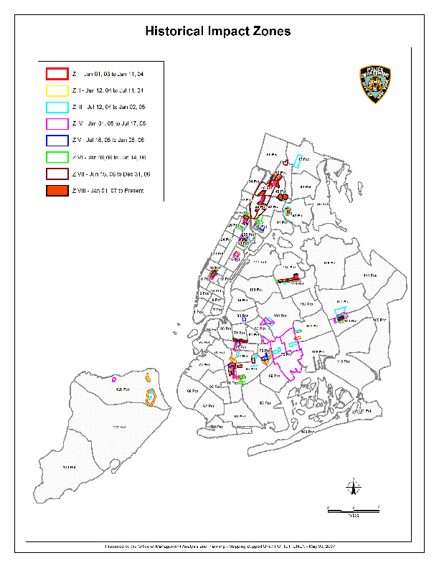Figure 1
Hot-Spots Policing Deployment Areas
The Data Set
Our analysis was based on seven longitudinal crime-rate time-series produced by the NYPD’s Crime Reporting system. The data included 202 monthly observations of each of the seven major crimes – murder, rape, robbery, burglary, grand larceny, felony assault, and auto theft – for seventy-three of the City’s seventy-six precincts covering the period April 1990 to December 2006. We excluded the 22nd Precinct encompassing Central Park from our analysis because there are no population statistics from which to calculate crime rates. We also excluded the 33rd and 34th Precincts – Washington Heights and Inwood - which were carved out of the 34th precinct in 1994. As a result of that carve out, neither crime nor population statistics were available for the all of the time periods used in the analysis.

Because the Crime Reporting system records crimes in their original classification period and corrections in the period when they are approved, there were periods in the data set when reported crime-rates were less than zero. When that occurred, we set the crime rate equal to zero. Comparisons of analyses done before and after these changes were not materially different. However, we were unable to identify the periods when these overstatements occurred. As a result, crime rates in those periods have not been adjusted. These changes did not involve a substantive number of periods for most crime rates. However, 99 entries out of a total of 14,744 total observations were changed for murder and 400 were changed for rape. We cannot rule out that this small number of reclassification changes had some impact on reported results but we do not expect the effects to be material.

The Evaluation Model

We employed a panel-data formulation of an interrupted-time-series model in our analysis. In its most general form, that model contains variables that relate to overall city trends, pre-Impact-Zone trends in the hot-spot precincts and post-
Impact-Zone trends in the hot-spot precincts. Our analysis involved doing separate evaluations of the impact of the hot-spots intervention for each of the seven major crimes.

In its most general form, the model we used for the analysis is a follows:
Crime rate = pre-intervention city-wide components
+ pre-intervention zone-precinct components
+ post-intervention zone-precinct components
Where the pre-intervention city-wide components are:
Constant + B₁ * period + B₂ * period_sq
The pre-intervention zone-precinct components are:
+ B₃ * z_noz + B₄ * znz_time + B₅ * znz_per2 (2003 zones)
+ B₆ * time_2004 + B₇ * z2004_per2 (2004 zones)
+ B₈ * time_2005 + B₉ * z2005_per2 (2005 zones)
+ B₁₀ * time_2006 + B₁₁ * z2006_per2 (2006 zones)
The Hot-Spots impact components of the model are:
+ B₁₂ * z_active + B₁₃ * active_time (impact measures)
+ B₁₄ * md_pst_per (zone-ended measure)
Definitions of each of the variables and their interpretation are presented in Table 2.

Table 2
Definition of Variables

Variable | Definition | Interpretation
period | Time-series variable ranging from 1 to 202 to reflect April 1990 to December 2006. | Reflects the overall crime trend in the city absent hot-spot policing.
period_sq | Period squared. | Measure declining/increasing returns to time of the NYPD core crime-fighting strategy for the city absent hot-spot policing.
z_noz | Dummy variable set equal to 1 for all precincts where Impact Zones were initiated in 2003. It is equal to zero for all other precincts. | Variable measures the difference in the base crime rate for the city (as indicated by the model constant) before the start of any zones and 2003 zone-precincts absent hot-spot policing.
znz_time | Interaction of the z_noz dummy variable with period. | Reflects the difference between crime trend in the 2003 zone-precincts and the city as a whole absent hot-spot policing.
znz_per2 | Interaction of the z_noz dummy variable with period_sq. | Measure declining/increasing returns to time of the NYPD core crime-fighting strategy for the 2003 zone-precincts absent hot-spot policing.
time_2004 | Interaction of a dummy variable set equal to 1 for all precincts where zones were started in 2004 with period. | Difference between crime trends in the 2004 zone-precincts and 2003 zone-precincts where zones w absent hot-spot policing.
time_2005 | Interaction of a dummy variable set equal to 1 for all precincts where zones were started in 2005 with period. | Measure declining/increasing returns to time of the NYPD core crime-fighting strategy for the 2004 zone-precincts.
time_2006 | Interaction of a dummy variable set equal to 1 for all precincts where zones were started in 2006 with period. | Difference between crime trends in 2005 zone-precincts and the 2003 zone-precincts w absent hot-spot policing .
z2004_per2 | Interaction of a dummy variable set equal to 1 for all precincts where zones were started in 2004 with period_sq. | Measure declining/increasing returns to time of the NYPD core crime-fighting strategy for the 2005 zone-precincts.
z2004_per2 | Interaction of a dummy variable set equal to 1 for all precincts where zones were started in 2005 with period_sq. | Difference between crime trends in 2006 zone precincts and 2003 zone-precincts absent hot-spot policing.
z2004_per2 | Interaction of a dummy variable set equal to 1 for all precincts where zones were started in 2006 with period_sq. | Measure declining/increasing returns to time of the NYPD core crime-fighting strategy for the 2006 zone precincts.
Z_active | Dummy variable set equal to one for any month when a zone is active in a precinct. | Measures the difference in the absolute number of crimes in the city and the zone precincts.
Active_time | Interaction of z_active with period. | Measures the impact of hot-spot policing on the decline in crime. Negative sign signifies an additional reduction in crime. Positive sign indicates a slowing in the rate of decline.
Md_pst_per | Interaction of a dummy variable set equal to one when any zone is either temporarily suspended or terminated with period. | Measures the impact of suspending or terminating a zone on the fall in crime rates.

This general model looks at the trends in crime over two time periods – pre-hot-spot policing and post-Impact-Zone policing. During the pre-intervention period, the city-wide components of the model isolate a city-wide base level of crime, an overall-city crime-trend and the change in that trend prior to the start of hot-spot policing. The pre-intervention Zone-precinct components of the model look for differences between the zone and non-zone precincts. Within the zone precincts, the model tests to see if there were statistically significant differences between the city as a whole and each of four groups of Zone-precincts prior to the intervention. Those zone-precinct groups are defined by their start-years with separate groupings for precincts where Zones were implemented in 2003, 2004, 2005, and 2006. The model allows Impact-Zone-groupings to differ from city-wide levels of crime, rates of change in crime rates and the trends in those rates of change.

Like the city-wide variables, pre-intervention Zone-precinct measures, grouped by the year their hot-spots were initiated, have intercepts (base crime level) that are allowed to differ from the city-wide average, rates of change in crime that may differ from the city-wide average and quadratic terms that indicates whether the rate of change in crime itself is changing. These quadratic terms can be interpreted as declining (positive sign) or increasing (negative sign) returns to time from pre-intervention policing strategies. They represent differences between the pre-Impact-Zone results in the Zone-precincts and the city as a whole. A negative sign for any of the quadratic terms indicates the policing strategy was, in effect, gathering steam with each successive month yielding higher levels of crime reduction than the prior month. In contrast, positive signs for these quadratic terms, as was the case for most crime categories, indicate that the rate of the drop in crime was slowing month-to-month.

The Hot-Spot-Impact section of the model tests for the effects of the Impact-Zone intervention on pre-existing crime trends. These measures indicate whether the hot-spot strategy had an incremental impact on crime above and beyond the historical downward city-wide trend plus the specific rates of crime-change in each of the Impact Zone start-year groupings. Specifically, the trend variable (active_time), measures the incremental change in the crime-rate due to Hot-Spots policing. In addition, the hot-spots section of the model also tests for what is called regression to the mean. If regression to the mean exists, the coefficient of the variable md_pst_per will be positive indicating that crime rates rose when Zones were suspended or permanently terminated.

As the results below show, not all of these factors were statistically significant for every crime category and some of the variables tested in the complete model were not significant in any final model. For clarity, factors that were not significant at the .1 level were not reported.

The model presented above can be categorized as a cross-sectional panel-data model or, in the parlance of the Criminal-Justice discipline, a two-level hierarchical model. The model was estimated using Maximum Likelihood Estimation. MLE estimation techniques were used to adjust for the possible bias that might be introduced by the trends in the crime-rates within each of precincts. Those tends would have biased the coefficient estimates, significance measures and standard errors produced by ordinary-least-squares models and led to unreliable results.

In addition to the results reported below and specified in the model above, we examined a three-level hierarchical formulation of the model where Impact Zones were clustered according to the year they were started. None of the alternative formulations of that model were significant. We also tested the impact of staffing levels - standardized both on a per-capita basis and per-square mile as a measure of patrol density – to determine the impact staffing had on post-hot-spot results. Both formulation of staffing proved to be proxies for the time components in the models described above with comparable results to those reported below. As a result, we completed the analysis using the model described above.

As part of our analysis, we also tested for differential results for Zone-precincts grouped by the years the Zones were started. That was done both by adding a third hierarchical level to the model that attempted to cluster Impact Zone precincts by the year the NYPD elected to start Zones in those precincts. Despite the application of a variety of optimization techniques and starting points for the models, none of them converged to a solution.

There are two interpretations for why neither of these modeling approaches failed to find differential levels of performance. First, it may be that there was insufficient variation among the groups to define an optimal solution. If that is the case, it suggests that there was little variation among the results for each of then start years and the results reported here are consistent across all start years.

A second explanation for the lack of significant results may lie in the unbalanced sample sizes, variations in start and stop dates, and lengths of intervention among the Zones. As Table 1 shows, the NYPD instituted Impact Zones in nineteen precincts in 2003 but only two new Zones in 2006. In addition, eight of the 2003 Impact Zone precincts had continuous or almost continuous Zones in place through 2006 while neither of the Zones started in 2006 were in place for more than six months. To the extent that is the cause of the results that were observed, there may have been year-to-year or precinct to-precinct variations in outcomes that we were unable to estimate.

In addition, we tested for differences for the Zone-precincts individually. Those tests were run using what are called random-effects models where each precinct is allowed to have a unique base-crime-level and crime-trend. When that formulation of the model was tested, we were unable to extract any statistically significant results. Again there are two explanations for why this may have occurred. First, it may be a reflection of the fact that there were no precinct-to-precinct variations in the results generated by the hot-spots strategy. Alternatively, the lack of significance could have been caused by the structure of the underlying data with differential start times, hot spots durations, and occasional Zone suspensions. We were unable to determine which of these explanations is correct. While the lack of differential results does not detract from our overall findings that, with one notable exception and one borderline case, the Impact-Zone strategy appears to have worked to reduce five of the seven major crimes. However, our inability to extract precinct-by-precinct differences in results made it impossible to test for the differential impact of specific intervention strategies.

Interpreting the Model

While the formulation of the model is complex, its interpretation is fairly straightforward. The coefficient for the city, Zone-precincts prior to intervention and the post–intervention results can be interpreted as representing the difference between the city-wide crime trends and those that occurred in precincts where Zones put in place before and after the introduction of Impact Zones in those precincts. To illustrate, let’s consider the results obtained from the murder-rate analysis reported in Table 3 below and presented graphically in the murder-rate analysis section below. The table shows a city-wide decline in the murder rate (as reflected in the variable “period”) of approximately .003 murders per thousand people per month for the city as a whole before hot spots policing was introduced. However, the model also indicates that murder rates in precincts chosen for 2003 Impact-Zones were declining faster than the city as a whole even before hot-spots policing was introduced. To find the pre-hot spots rate of decline in the precincts chosen for 2003 Impact Zones, we add the coefficient for period (-.00281) to znz_time (-.00019) - the coefficient for the 2003 Impact Zone precincts - to get the rate-of-decline in murders in those precincts (-.000471). That indicates that murder rates were falling nearly 68% faster in precincts chosen for 2003 Impact Zones, albeit from a higher crime level, than they were in the city as a whole even without the introduction of Impact Zones.

The hot-spot impact section of the model allowed us to measure whether the introduction of Impact Zones had a statistically significant impact on that underlying trend above and beyond what would have been expected by a continuation of the pre-intervention trend. We measured the hot-spots policing impact on the rate-of-change in crime through the “active_time” variable. If the coefficient for that variable is negative and statistically significant, it indicates that the Zone was effective in speeding the reduction in crime. Continuing with the murder-rate example, the murder analysis coefficient for active_time was equal to -.00011 with a p value of .045 which is below the traditionally used .05 cutoff point for significance. That suggests that the total rate-of-decline in murder-rates in precincts where Impact Zones were started in 2003 was -.00482 - the sum of the city trend, the pre-intervention Zone trend and the impact of the intervention. That change can be interpreted in one of two ways. First, the impact of the Zones added 24% to the crime-reduction rates that existed prior to implementing the hot-spot strategy. Alternatively, the model shows that 19.4% of the drop in crime experienced during the time the 2003 Zones were active can be attributed to the Zones.

Results of the Analysis

Because there is no generally accepted way to aggregate crimes, the results of the analysis are shown for each crime and summarized qualitatively at the end of the results section. Our presentation of the results for each crime will follow the general explanation presented above and add additional insights into the underlying trends and results achieved in Zones started after 2003. We also found evidence that the policing strategies the NYPD was using prior to the introduction of Impact Zones was beginning to produce declining returns.
Table 3
 | Murder | Rape | Robbery | Assault | GL | Burglary | GLMV
City
Constant | .02672 | .03566 | 1.3335 | .51829 | 1.97094 | 1.53560 | 2.0070
Period | -.00028 | -.00022 | -.01241 | -.00268 | -.01056 | -.01363 | -.02258
period_sq | 8.9e-07 | 5.7e-07 | 8.9e-07 | 4.1e-06 | 2.6e-05 | 3.6e-05 | 7.4e-05
Zones Precincts
z_noz | .19783 | .23443 | .01978 | .32085 | NS | .47577  P<.05 | -.30714
znz_time | -.00019 | -.00015 | -.00482 | -.00215 | -.00852 | -.00133 | -.33071
znz_per2 | 6.3e-07 | 4.2e-07  P<.01 | 6.3e-07 | 5.5e-06 | 4.1e-05 | NS | -8.5e-06  P<.01
time_2004 | .00003  P<.05 | NS | .00683 | .00367 | .012427 | .00128 | -.00370
z2004_per2 | NS | 2.3e-07  P<.01 | NS | -.00001 | 4.0e-05  P<.01 | NS | NS
time_2005 | -.00003  P<.05 | .00004  P<.05 | -.00102 | -.00191 | .01179 | .00159 | .00189
z2005_per2 | NS | NS | NS | 7.8e-06  P<.01 | 3.5e-05  P<.05 | NS | NS
time_2006 | -.00046 | -.00049 | -.03506 | -.00394 | -.05927 | -.03998 | .00512
z2006_per2 | 1.5e-06 | 1.7e-06 | 1.5e-06 | NS | NS | 9.1e-05 | NS
Hot-Spot Impact
z_active | .01878  P=.054 | .06897 | .01879 | .17792  P<.05 | 4.18013 | .06908  P<.1 | -2.3620
active_time | -.00011  P<.05 | -.00038 | -.00365 | -.00112  P<.05 | -.02546 | -.00138  P=.116 | .01381
md_pst_per | NS | NS | NS | .00059  P<.01 | NS | .00048 | -.00069
Hot-Spot Policing Analysis Results

Table 3 above should be interpreted as follows. There are three sections in the output corresponding to the three elements of the model presented above. The first section presents the base crime level (constant), crime trend (period) and an indicator of changing returns-to-time (period_sq). If the value of “period” is negative, it indicates a month-to-month decline in the crime rate. If it is positive, the crime rate is rising. If the “period_sq” variable is positive, it indicates that the rate of decline in crime is slowing over time at approximately twice the rate indicated by the coefficient. If that value is less than zero, it indicates that the decline in crime is accelerating at twice the value of the coefficient per month.

Note the period_sq coefficients have been presented in scientific notation because of their small size and space limitations in the table. Using the coefficient for period_sq in the murder column as an example, the value 8.9e-07 can be converted to a decimal by putting six zeros after the decimal point – one less than the number after the e - and following that with the number 89. That makes 8.9e-07 is equivalent to .00000089.

The second section of the table reflects the level and trend in crime in the Zone-precincts prior to the instigation of the hot spots strategy. The three variables z_noz, znz_time and znz_per2 are analogous to the three variables for the city. The variable z_noz represent the difference between the base rate of crime in the precincts where Zones started in 2003 and the city as a whole. The variable znz_time represents the difference in the monthly change in crime rates in the 2003 Zone-precincts versus the change in the crime rate for the city as a whole. Finally, znz_per2 is a measure of the difference in the acceleration or deceleration in the crime rate for the 2003 Zone-precincts versus the city. In all cases, the 2003 Zone-precinct measure is the sum of the city-wide coefficient and the 2003 Zone-precinct coefficient.

Interpreting the variables time_200X and z200X_per2 follow the same model. Whenever these variables are significant, they represent the difference between what happened in the 2003 Zone-precincts and those implemented in 2004. For example, the murder rate in precincts chosen for 2004 Zone introductions had a crime rate that was rising .00003 murders per month faster than the 2003 Impact Zones, while in Zones chosen for 2005 Zone starts had a murder rate that was falling .00003 murders per month faster than the 2003 Zone-precincts. Results for time_2006 can be interpreted in the same way. Similarly, z200X_per2 indicates the difference between the returns to time in the 2003 Zone-precincts and those started in 200X. For example, the rate of decline of murder in Zone precincts that were started in 2006 was falling roughly .00003 murders per month.

The final section of Table 3 reports on the results of the hot-spots initiative. Here z_active shows the difference between the Zone precincts and the city-wide average when the Zones started. Because of variations in the start dates for the Zone interventions, the z_active coefficient is difficult to interpret outside of its sign. Using the results for murder as an example, the model indicates that murder rates were higher in the precincts chosen for hot-spots policing than they were in other areas of the city. The active_time variable measures the impact of the Zone-interventions on crime. If active_time is negative, it indicates that the Zone-intervention added to the reduction in crime above and beyond what was occurring prior to that intervention. In the case of murder, hot-spots policing reduced crime by .00011 murders per month. The final variable md_pst_per indicated whether crime continued to decrease (negative sign), increased (positive sign) or had no impact (coefficient was not significant) when the Zone was suspended or terminated. In effect, it measures regression to the mean.

In each of the crime-specific results presented above, we have provided overall effectiveness measures as well as impact measures for each of the groups of precincts based on their start years and percentage-impact measures. While the overall results as indicated by the active_time variables for each crime may be interpreted as strong evidence of the effectiveness of the Impact Zone-policing strategy, the percentage interpretations and Zone-year-specific results are less robust for the reasons stared above. As a result, those findings should only be used as an indicator of possible variations in the magnitude of crime changes and not construed as precise measures of relative effect.

Murder Results
Prior to implementing hot spots policing, the model shows that murder rates were falling in the city as a whole (period = -.00028) with rates declining faster than that base rate in the 2003 /2004 (znz_time = -.00019) , 2005 (time_2005 = .00003) and 2006 (time_2006 = -.00046) Zone-precincts while murder rates were declining more slowly in the 2004 Zone precincts (time_2004 = .00019). However, they were falling from a higher level of crime with incidents of murder in Zone-precinct (z_noz) .198 murders per-thousand-people higher than the city as a whole. In addition, there were signs of declining returns-to-time in the city (period_sq = 8.9e-07), the Zones as a whole (znz_per2 = 6.3e-07) and the Zones started in 2006 (z2006_per2 = 1.5e-06). As discussed above, these “quadratic” terms indicate that the rate of reduction in murder rates was declining on a month-to-month basis.

The hot-spots section of the model indicates that the precincts chosen for hot- spots interventions experienced higher overall rates of crime at the time when the intervention was started (z_active = .01878). It also shows that the intervention was successful. The rate of change in the crime rate during the intervention (active_time = -.00011) was 24% higher than it was before the intervention began with the strongest results in the 2003 and 2004 Zone-precincts (see Figure 2).

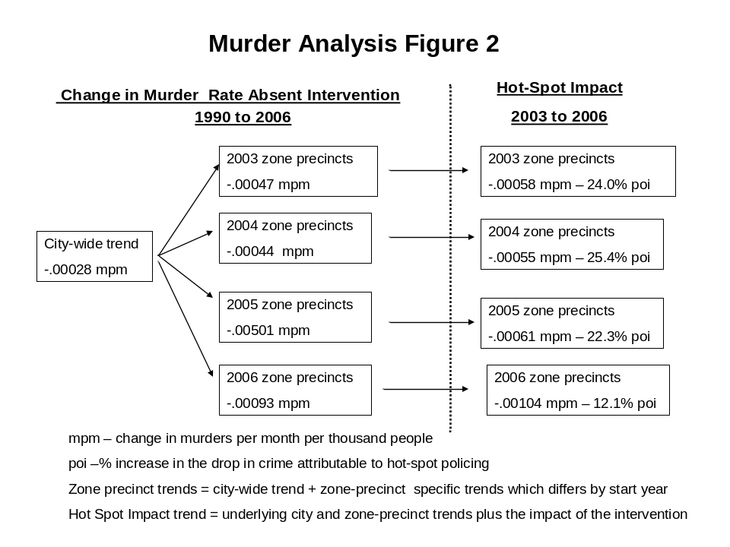

Rape Results
The results show a similar pattern for rape. Prior to the intervention, rape rates were falling in the city as a whole (period = -.00028) with rates falling faster in the 2003, 2004 and 2006 Zone-precincts. Again, there were declining returns-to-time for the city as a whole with similarly higher rates-of-decay for the 2003 and 2005 zone-precincts and even faster rates-of-decay in the 2004 and 2006 Zone-precincts.

Again, the hot-spots variables indicate that Impact Zones were effective in further reducing the incidence of rape (active_time = -.00038) from a level that was higher than the overall city when the Zones were instigated (z_active = .01878). That equates to a more than a doubling in the rate of decline in incidents of rape in the 2003 Zone precincts compared to the pre-intervention trend. As figure 3 shows, the results were felt in all of the Zone-year precincts but appear to have been most pronounced in the precincts where Zones were started between 2003 and 2005. However, that difference may only reflect the fact that only two Zone-precincts were started in 2006, the lower overall level of rapes across the city and the Zone-precincts by that point in time or the approximately six-month duration of the interventions started in 2006.

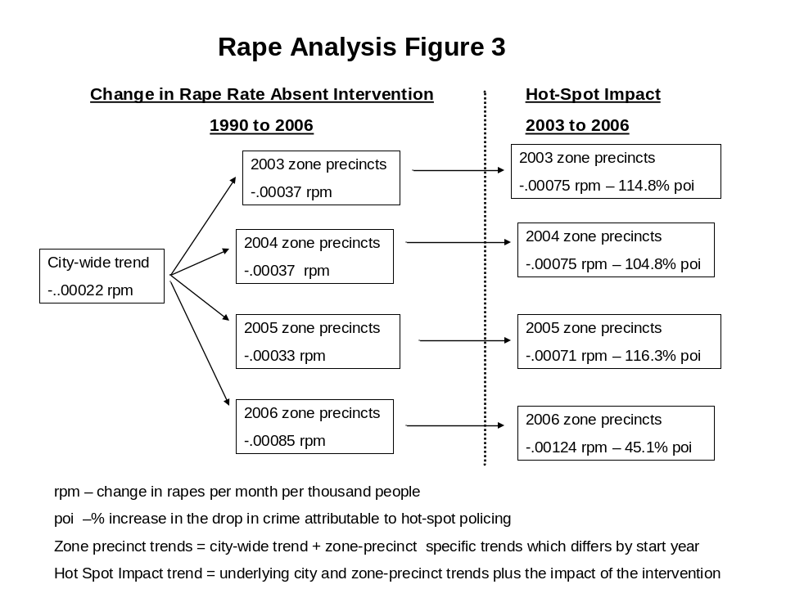

Robbery Results
Robbery results mirror those found for murder and rape. The pre-intervention city-wide robbery trend was down with the 2003, 2005 and 2006 Zone precincts experiencing faster drops in robbery rates than the city overall. As it was for murder, robbery rates were dropping more slowly for the 2004 Impact-Zones than they were for the other three Zone-precinct-groupings (time_2004 = .00683). Again, there were declining pre-intervention returns-to-time for the city as a whole and the each of Zone-start-year groups.

Consistent with the results reported for murder and rape, the Impact-Zone intervention had a statistically significant impact on the drop in crime (active_time = -.00365). That equated to an overall acceleration of 21% in the drop in crime (see Figure 4) with the strongest relative performance in the 2004 Zone-precincts and the lowest in the 2006 Zone-precincts.

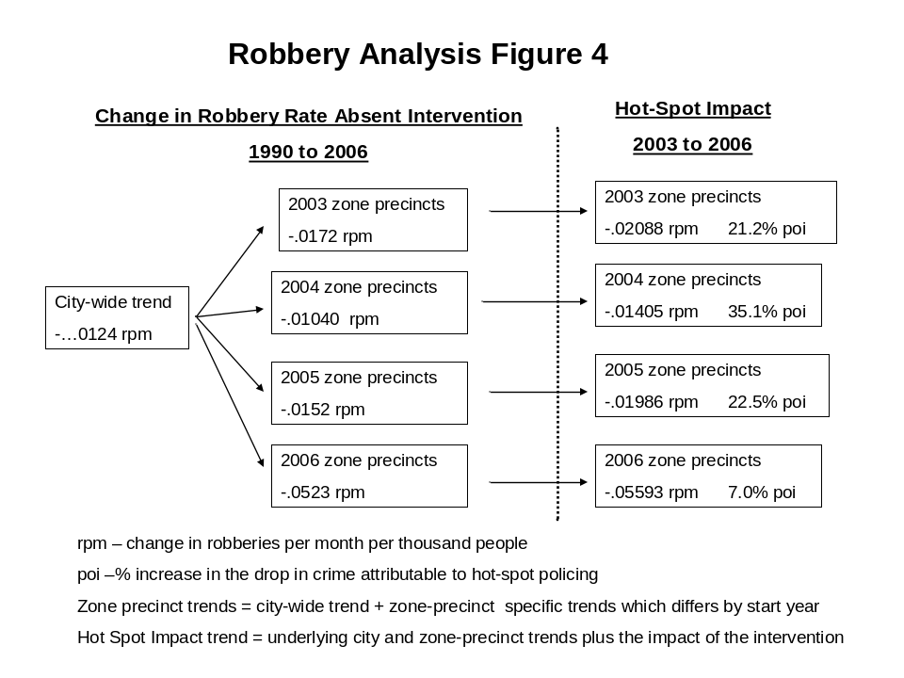

Assault Results
Results for assault were consistent with the other crimes-against-person. Pre-Impact Zone assault-rates were dropping in the city and in the Zones. Again, there were declining returns both at the city level and in each of the Zone-start-year groupings. As it was with the prior three crime-categories, crime rates were higher in the Zone-precincts at the start of hot-spots policing and fell faster than the city after the start of the Impact Zones. That translates into an overall 23% acceleration in the drop in assaults while the Impact Zones were active. Further, there is evidence that the impact was greatest on Impact Zones that started in 2004 (see Figure 5).
However, there was evidence of regression to the mean for assault. While the Zones were either suspended and after they were terminated, the rate of decline in assaults slowed (md_pst_per = .00059).
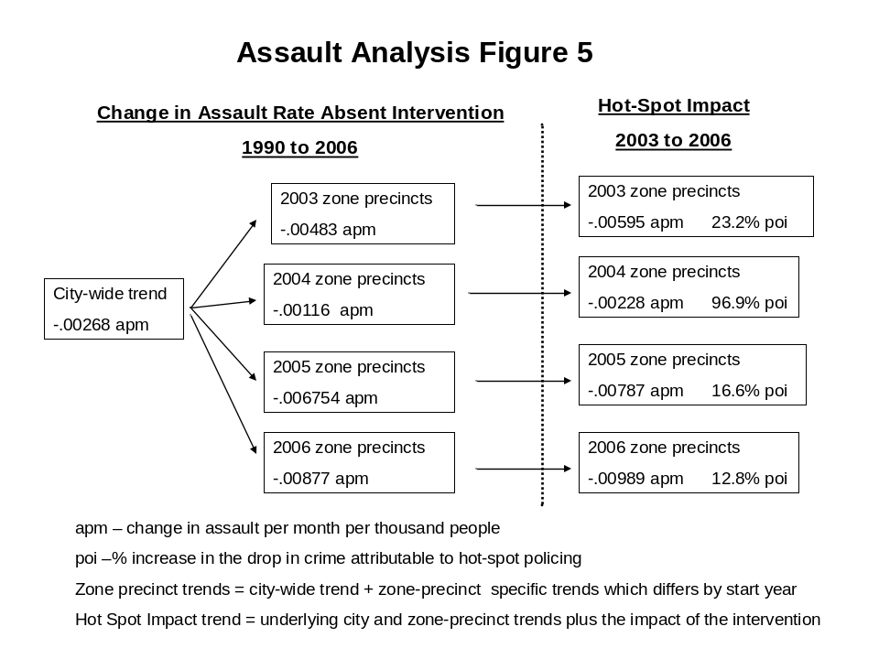
Grand Larceny Results
The patterns for grand larceny were again similar to the first four crime categories. Before the introduction of hot-spots policing, city-wide grand-larceny rates were declining with Impact-Zone-precinct rates going down faster than the city as a whole. Again there were declining returns-to-time both at the city level and within the Impact-Zone precincts.

When the Impact-Zone interventions started, the model suggests that grand larceny levels in the Zone-precincts were higher than they were city-wide. Consistent with the results presents thus far, the rate-of-decline in grand larcenies while the Zones were active in the precincts more than doubled the drop in grand-larceny rates compared to the 2003 Zone-precincts with indications of even stronger effects in 2004 and 2005 Zone-precincts (see Figure 6).

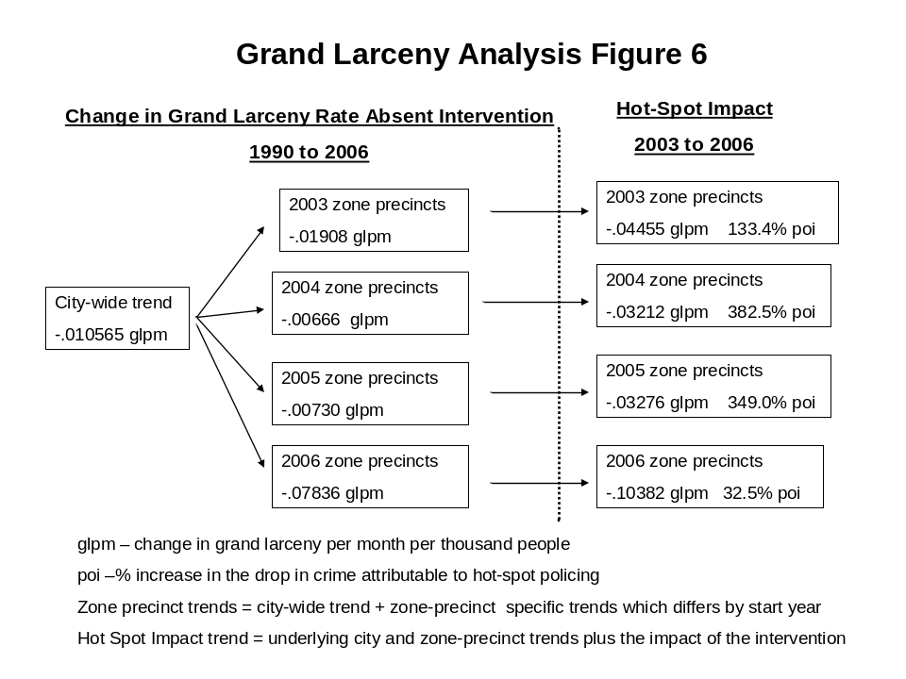

Burglary Results
Pre-hot-spots-policing trends for burglary were consistent with what we have presented thus far. Burglary rates were higher in the Zone-precincts that they were in the city as a whole but dropping faster in the precincts selected for inclusion in the hot spots policing initiative. However, outcomes for burglary were significantly different. First, the hot-spots-policing impact measurement for burglary was not statistically significant. Plus, there is statistically-significant evidence of a drop in the rate-of-decline in crime when the Zones were either suspended or terminated. Those results suggest that Impact Zones did not have a material impact on the pattern of falling burglaries that existed prior to hot spots policing but that there was a negative impact when the Zones were inactive.

Grand Larceny Motor Vehicle Results
The pattern in auto theft differed both pre- and post-intervention. First, auto-theft rates were lower in the precincts chosen for hot-spots policing than they were for the city as a whole. However, the pre-intervention pattern of declining crime rates, with higher Zone-precinct rates, and declining returns-to-time was consistent with the other crime-categories. At the start of the Impact Zones, auto-theft rates appear to have been significantly lower in the Zone-precincts in sharp contrast to evidence of higher rates across the other six major crimes. In addition, the model showed a small but statistically-significant slowing the rate of decline in auto-theft while the Zones were active. Overall, the Zones reduced the drop in auto thefts when compared to the pre-intervention period by 3.9% with consistent results across all four Zone-start years. Interestingly, when the Zones were suspended or terminated, the rate of change in auto-theft rates sped up (md_pst_per = .00069).
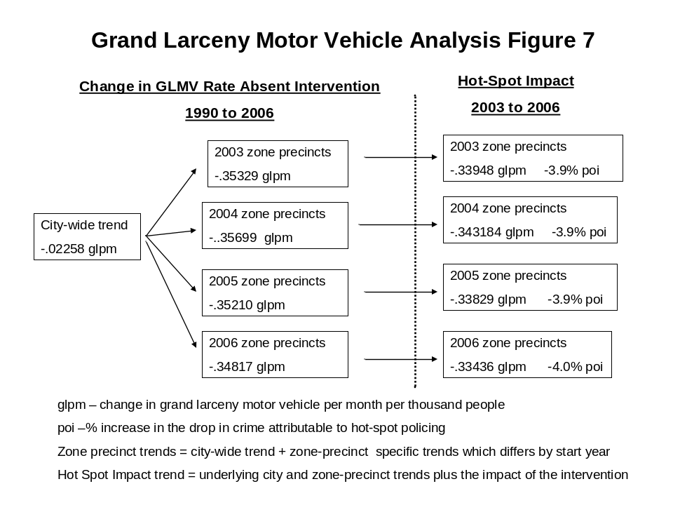

Summary of Statistical Analysis of Operation Impact
Overall, it appears that the impact-policing strategy was effective against visible crimes-against-people. There were significant declines in crime rates for murder, rape, robbery, assault, and grand larceny across all of the Zone-start years. However, that result did not carry over for burglary, where no statistically significant impact was found, and auto theft, where the rates of decline slowed while the Zones were active.

The lack of results in burglary may be an artifact of the nature of the crime. Unlike the other categories, burglaries do not occur on the street and it may have been outside the scope and focus of hot-spots policing strategies to give priority to that category of crime. The findings for auto theft are a bit more difficult to explain. It may be that the rate of motor-vehicle theft was so low at the start of the interventions that further reductions were hard to achieve. Alternatively, it might have been the case that since auto theft was not a priority of Impact Zones they might not have received added attention in response to evidence that the city-wide and Zone-precinct trends were starting to change. Finally, evidence from a study conducted by the program evaluation team suggests that there may have been some amount of gentrification during the period when the Impact Zones were active. To the extent that is true, the change in auto-theft rates might reflect an increase in the number and types of vehicles in the Zone precincts. Without further study, we are unable to determine which if any of these possible explanations for the impact of hot spots policing on burglary and auto-theft rates explains what we observed in the models.

Table 5
Overall Impact of Hot-Spot Policing
Compared with Zones Started in 2003

Crime Category | Change Crime Rate | % Change in Drop in Crime Rates Due to Impact Zones | % of Drop in Crime During Hot-Spot Intervention Due to Impact Zones
Murder | -0.000112 | 24.0% | 19.4%
Rape | -0.0003838 | 104.8% | 51.2%
Robbery | -0.0036496 | 21.2% | 17.5%
Assault | -0.0011215 | 23.2% | 18.8%
Grand Larceny | -0.0254632 | 133.4% | 57.2%
Burglary | -0.0013797 | 9.2% | 8.4%
GLMV | 0.0138108 | -3.9% | -4.1%

Managing Impact Zones
At least since the mid 1990s, precinct commanders in NYPD have played a much more visible role in the management of crime reduction in the City. When the weekly Compstat meeting convenes to review crime trends and police performance in the management of crime, it is precinct commanders who are front and center with their teams reporting on their progress and answering questions. The dialogue in the meetings is all about the evidence presented in graphs, maps and charts. Throughout all the early years of NYPDs celebrated, historic turnaround of crime, the effort was supported by an upward surge in police resources coming from Safe Streets, Safe City, or federal funding for police and the fight against crime. Today, and in the past several years, with no diminution of pressure to reduce crime further, the context has been one of declining police-personnel. It is not surprising therefore that in meeting after meeting with precinct commanders who had received allotments of Impact-Zone staffing, there was enthusiasm for the program and gratitude for having been selected. In most cases, the enthusiasm and gratitude was fueled by the victories, sometimes dramatic, they could report in reducing crime in the Zones. They also valued being included in one of the Department’s key program-initiatives.

The initial design of the study was predicated on the assumption that the success of Operation Impact would vary, potentially widely, across the diverse “hot spots” selected as Zones. We intended the field interviews to provide insights into the different deployment strategies and activity pattern in the different precincts. As reported above we did not find significant differences in crime reduction success rates at the precinct level. Consequently, there was no significant variation in performance to explain. Nevertheless, the field interviews were useful in shedding light on an often neglected aspect of program evaluation, the experience of the program implementers at the local level.

In contrast to the design of our statistical study reported above, our data from interviews and site visits lacks longitudinal and comparative depth. We did not interview precinct commanders who did not receive Impact-Zone deployments, and we did not interview commanders before their precincts were selected to receive an Impact Zone. Therefore, limited weight can be given to this part of the assessment. Nevertheless, after meeting with commanders in more than half of the participating precincts we can safely report that the introduction of hot-spots policing changes significantly the way crime was analyzed and monitored at the local level, and the degree to which the forces under a precinct commander were mobilized to make as certain as is possible that crime was deterred. If crime goes down in an assigned hot spot, the highest concentration of crime in the precinct, and if steps are taken to guard against any displacement or to respond to it at the first suggestion, the likelihood that crime will decline for the precinct as a whole is quite high. This, of course, is what the statistical analysis presented here found. Viewed in this way, Operation Impact has to be understood to be both a specific tactic but also a strategy of evidence-based crime-fighting at the precinct, borough and City-wide level. The focus on the outcome of violent-crime reduction is shared at all levels, the diagnosis of problem areas is shared, and the monitoring and analysis is focused on the same priority areas and crime patterns throughout the City. This constitutes a notable intensification of NYPD’s emerging pattern of pervasive utilization of evidence-based, outcome-oriented policing, from the precinct hot-spots to the Real Time Crime Center.

Methodological Note on this Empirical Assessment of Operation Impact
None of the “experiments” in other cities of limited duration in a small number of randomly selected blocks, often with proxy measures (such as “crime calls”) of the outcome crime-reduction, can compare with the robustness of the results produced over the past four and a half years of hot-spots policing in New York City. Operation Impact has been studied here but it is not itself a study. Operation Impact is the actual, primary crime-fighting strategy of America’s largest city, with all of the complex institutional context that entails. While lacking the power of a random assignment study, the rigorous quasi-experimental design used in the present study, combined with the organizational context, makes up in the extent and depth of real world data what it loses in departing from the methodological rigor -- but artificial nature --of earlier classical experimental efforts to assess the impact of hot spots policing. Both make a contribution to advancing knowledge of what works and does not work in urban policing.

Appendix 1

Population and Growth Rates by Precinct

Precinct | Precinct Number | 1990 Census | 2000 Census | Monthly CAG
Tribeca/Wall Street | 1 | 29,667 | 38,470 | 0.241%
Chinatown/Little Italy | 5 | 44,147 | 45,694 | 0.032%
Greenwich Village | 6 | 89,860 | 88,805 | -0.011%
Lower East Village | 7 | 15,266 | 13,849 | -0.090%
East Village | 9 | 108,678 | 111,735 | 0.026%
Chelsea | 10 | 39,992 | 40,104 | 0.003%
Gramercy | 13 | 64,213 | 64,750 | 0.008%
Midtown South | 14 | 53,425 | 55,731 | 0.039%
Midtown | 17 | 73,156 | 76,360 | 0.040%
Midtown North | 18 | 24,239 | 23,763 | -0.018%
East Side | 19 | 203,479 | 208,675 | 0.023%
West Side/Central Park | 20 | 86,718 | 88,821 | 0.022%
Upper East Side | 23 | 73,838 | 78,726 | 0.059%
Upper West Side | 24 | 117,334 | 111,709 | -0.045%
East Harlem | 25 | 38,855 | 41,760 | 0.067%
Morningside Heights | 26 | 52,717 | 54,560 | 0.032%
Central Harlem | 28 | 34,738 | 38,338 | 0.091%
Harlem | 30 | 57,270 | 60,180 | 0.046%
Harlem | 32 | 63,533 | 68,081 | 0.064%
South Bronx | 40 | 75,344 | 80,897 | 0.066%
Hunts Point | 41 | 55,882 | 61,506 | 0.089%
Tremont | 42 | 59,321 | 71,059 | 0.167%
Soundview | 43 | 164,056 | 176,352 | 0.067%
Morris Heights | 44 | 115,375 | 134,518 | 0.142%
Schuylerville | 45 | 90,821 | 96,447 | 0.056%
University Heights | 46 | 117,224 | 128,176 | 0.083%
Eastchester | 47 | 137,549 | 156,922 | 0.122%
Fordham | 48 | 72,441 | 80,062 | 0.093%
Baychester | 49 | 98,319 | 112,083 | 0.121%
Riverdale | 50 | 92,141 | 96,680 | 0.045%
Bedford park | 52 | 125,292 | 137,925 | 0.089%
Coney Island | 60 | 97,585 | 100,867 | 0.031%
Sheepshead Bay | 61 | 146,692 | 163,381 | 0.100%
Bensonhurst | 62 | 149,215 | 171,008 | 0.126%
Flatlands/Mill Basin | 63 | 88,513 | 100,761 | 0.120%
Borough Park | 66 | 159,127 | 184,093 | 0.135%
East Flatbush | 67 | 154,429 | 161,661 | 0.042%
Bay Ridge | 68 | 110,269 | 122,909 | 0.101%
Canarsie | 69 | 80,982 | 100,830 | 0.203%
Kensington | 70 | 161,916 | 168,880 | 0.039%
Flatbush | 71 | 111,677 | 105,136 | -0.056%
Sunset Park | 72 | 105,349 | 123,118 | 0.144%
Bedford-Stuyvesant | 73 | 85,935 | 86,174 | 0.003%
East New York | 75 | 151,551 | 163,890 | 0.073%
Carroll Gardens/Red Hook | 76 | 40,250 | 41,559 | 0.030%
Crown Heights | 77 | 98,560 | 96,905 | -0.016%
Park Slope | 78 | 59,801 | 60,555 | 0.012%
Bedford-Stuyvesant | 79 | 80,401 | 82,220 | 0.021%
Brownsville | 81 | 60,385 | 63,095 | 0.041%
Bushwick | 83 | 100,167 | 101,381 | 0.011%
Brooklyn Heights | 84 | 53,689 | 57,143 | 0.058%
Fort Greene | 88 | 43,595 | 44,569 | 0.020%
Williamsburg | 90 | 106,969 | 111,027 | 0.034%
Greenpoint | 94 | 48,337 | 50,547 | 0.041%
Rockaway | 100 | 43,634 | 46,890 | 0.067%
Far Rockaway | 101 | 60,553 | 119,592 | 0.632%
Richmond Hill | 102 | 114,226 | 148,924 | 0.246%
Jamaica | 103 | 105,865 | 117,549 | 0.097%
Ridgewood/Middle Village/Glendale | 104 | 146,024 | 163,936 | 0.107%
Queens Village | 105 | 174,264 | 196,051 | 0.109%
Ozone Park | 106 | 96,703 | 136,112 | 0.317%
Fresh Meadows | 107 | 139,552 | 156,649 | 0.107%
Long Island City | 108 | 96,872 | 111,218 | 0.128%
Flushing | 109 | 221,832 | 245,071 | 0.092%
Elmhurst | 110 | 139,849 | 170,885 | 0.186%
Bayside | 111 | 114,529 | 121,296 | 0.053%
Forest Hill | 112 | 105,564 | 114,987 | 0.079%
Jamaica | 113 | 86,928 | 97,964 | 0.111%
Astoria | 114 | 173,403 | 196,478 | 0.116%
Jackson Heights | 115 | 128,925 | 169,778 | 0.255%
St. George | 120 | 139,413 | 164,316 | 0.152%
New Dorp | 122 | 113,628 | 127,420 | 0.106%
Tottenville | 123 | 125,937 | 151,992 | 0.174%

Bibliography
Bayley, David, Police for the Future (Oxford, 1994)

Braga, A., et al., 2001. “The Effects of Hot spots Policing on Crime.” ANNALS, American Academy of Political and Social Sciences. 578.

Clarke, R. V.,1992. “Situational crime prevention: Theory and Practice.” British Journal of Criminology 20: 136-147.

Eck, J. and J. Wartell,1996. Reducing Crime and Drug Dealing by Improving Place Management: A Randomized Experiment. Report to the San Diego Police Department. Washington, DC: Police Executive Research Forum.

Goldstein, H.1990. Problem-Oriented Policing. New York: McGraw-Hill.

Kelling, G., T. Pate, D. Dieckman, and C.E. Brown, The Kansas City Preventative Patrol Experiment: Technical Report. Washington, DC: Police Foundation.

Kelling, G. and W.H. Souza, Jr. 2001. Do Police Matter? An Analysis of the Impact of New York City’s Police Reforms Civic Report 22. New York: Manhattan Institute for Policy Research.

Kansas City Police Department, 1977. Response Time Analysis. Kansas City, MO: Kansas City Police Department.

Leavitt, Steven, D., “Understanding Why Crime Fell in the 1990s: Four Factors that Explain the Decline and Six that Do Not,” Journal of Economic Perspectives, Volume 18, Number 1, Winter 2004.

National Research Council, 2003. Fairness and Effectiveness in Policing: The Evidence. Washington, DC. National Academy Press.

Sherman, L. and D. Weisburd, 1995. General Deterrent Effects of Police Patrol in Crime “Hot Spots:” A Randomized, Controlled Trial. Justice Quarterly 12:625-648.

Smith, Dennis C and Joseph Benning,“ 2004. “An Empirical Assessment of Seven Years of SATCOM: The NYPD Command Structure in Brooklyn North.” Report to NYPD.

Smith, Dennis C., & Bratton, William J., 2001. “Performance Management in New York City: Compstat and the Revolution in Police Management”, from Quicker, Better, Cheaper? Managing Performance in American Government. Edited by Dall Forsythe. Rockefeller Institute Press, pgs. 453-482

Smith, Dennis C. and Robert Purtell, 2005, “Managing Crime Counts: An Assessment of the Quality Control of NYPD Crime Data.” Report to NYPD.

Spelman, William, and D. K. Brown, 1981. Calling the Police: A Replication of the Citizen Reporting Component of the Kansas City Response Time Analysis. Washington, DC: Police Executive Research Forum.

Spelman, William,1995. Criminal Careers of Public Places. In J.E. Eck and D. Weisburd, eds. Crime and Place, Crime Prevention Studies 4. Monsey, NY: Criminal Justice Press.

Swartz, C., 2000. The Spatial Analysis of Crime. What social scientists have learned. Pp. 33-46 in Analyzing Crime Patterns: Frontiers of Practice, V Goldsmith, P.G. McGuire, and T. A. Ross, eds. Thousand Oaks, CA: Sage.

Weisburd, David and Braga A., ed., Police Innovation (Cambridge University Press, 2006)

Weisburd, David.. and Steven Mastrofski, A.M. McNally and R. Greenspan, 2001. “Compstat and Organizational Change: Findings from a National Survey.” Report submitted to The National Institute of Justice.

Wilson, James Q. Varieties of Police Behavior: The Management of Law and Order in Eight Communities (Harvard University Press,1968)

Wilson, 1968,63.
Bayley, 1994, 3.
James Q. Wilson, Varieties of Police Behavior ( Cambridge, 1968, 60)
This imbedded dynamic pattern of crime made any evaluation of impact of an intervention triply complex: any changes in the precincts with Zones had to be seen in the context of the overall City trends, the specific precinct trends, and the fact that rates of change were changing at different rates for different crimes, in different parts of the City.
Leavitt, Steven, D., “Understanding Why Crime Fell in the 1990s: Four Factors that Explain the Decline and Six that Do Not,” Journal of Economic Perspectives, Volume 18, Number 1, Winter 2004.
Thomas J. Lueck, “Serious Crime Declines Again in New York at a Rate Outpacing the Nation’s,” New York Times, June 7, 2005.
Another result of Operation Impact worthy of study is its efficacy as a training strategy. In discussions with precinct commanders it was clear that they counted, and took pride in, the number of Impact Zone officers they were able to retain after they completed their Zone assignment.
Precinct commanders interviewed were uniformly enthusiastic about Operation Impact, and the fact that they were part of it, but did voice some reservations about the about of central control exercised over the definition of boundaries. They wanted to be able to make adjustments, for example in block parameters of Zones, without awaiting approval from headquarters. This was a difficult feature of the program to relax because the idea was to test the efficacy of sustained policing in a fixed area and time. By the time of the study some experimentation with limited local discretion was being tested.
NEWS from the BLUE ROOM, January 13, 2005. http://www.nyc/recent_events.html
Weisburd, Mastrofski and Greenspan, 2001.
Weisburd, David and Braga A., ed., Police Innovation ( Cambridge University Press, 2006)
Herman Goldstein, Problem Oriented Policing (Tempe University Press, 1990) and R. V. Clarke, Situational Crime Prevention,
They cite Lawrence Sherman, et al., 1989;Weisburd and Green, 1994; Spelman, 1995; Swartz, 2000
The one exception to that rule was the impact coefficient for burglary – “active_time”. For consistency, we did report that coefficient and indicated its p value of .116.
It is important to remember that murder, arguably the most violent crime, even at its peak in 1990 was a rare occurrence. With 2,200 homicides in 1990, in a city of 7,305,000 inhabitants, there were .30 victimization per thousand. By 2006, with a city that was almost 8 million, homicides were far rarer: .07 per 1,000.
That is the sum of the pre-zone city and zone-precinct trends plus the differential impact produced by the zone.
All coefficients are significant with p<.0001 except where indicated. NS indicates that the parameter estimates for the indicated variable were not significant at the .1 level. CHI² < .0001 for all regressions.
Where the quadratic term for a specific year as in z2004_per2 are not statistically significant, it indicates that zone-precinct group’s performance could not be distinguished statistically from the trend in 2003. Where a quadratic term was significant as it was for 2005, the znz_per2 and z2005_per2 coefficients must be added to determine the rate for the 2004 group of zone-precincts. All values within 95% confidence intervals for all of the z_active impact variables where statistically significant results were reported had negative signs.
The lack of significance for time_2004 suggests that the rate of change in rape rates was statistically identical to the 2003 zone-precincts.
It bears repeating that the primary raison d’etre for Operation Impact was reducing violent crime.
Negative signs for Crime Rate Change indicate that the hot spots strategy accelerated the month-to-month drop in crime. Positive signs indicate a slowing in the rate of decline in crime.
This is the ratio of the impact of the hot spots interventions to the pre-intervention rate of decline in month-to-month crime rates. Positive signs indicate that impact-zone policing added to crime reduction.
This is the ratio of the Impact Zone impact to the sum of the city-wide trend, the pre-intervention change in crime in the 2003 zone-precincts and the impact of hot spots policing. Because of data issues, we could not find a way to develop a weighted average that would reflect the proportional impact of each zone-start year on the overall average. Positive signs indicate that Impact Zone policing added to the overall reduction in crime.

